ELECTROLYTE PLASMA TREATMENT

The method of electrolyte plasma treatment is designed for removing microelevations from the product surface that leads to roughness decrease and surface specularity increase. Along with microelevations, foreign particulates, annealing colors, scales and various contaminations are removed. The surface is deoiled.
The polishing process occurs when the anode (product) is immersed in the electrolyte. At the same time, constant voltage of 200-350 V is applied to the product which causes the pulsed electrical discharges acting on the product surface.
Treated materials: products from stainless, alloyed and low-alloy steels, nickel alloys, copper and copper alloys, aluminum and aluminum alloys, titanium and magnesium alloys.

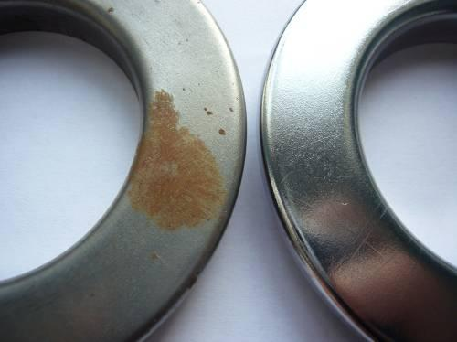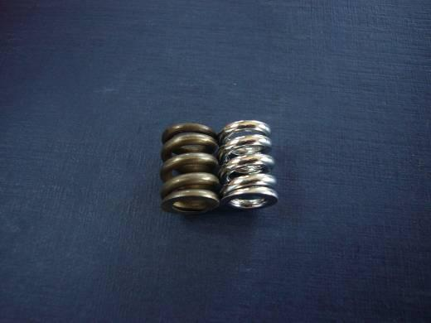
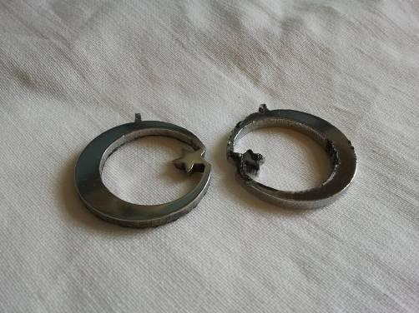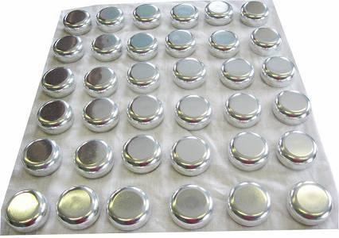

Process
The process lies in the electrolyte that contains inorganic acid salts. The salt concentration changes in the range from 1 to 10% depending on the material of the treated product. The electrolyte heating up to 60...90 ^{о}С is required before polishing.
The working voltage at polishing is 200…400 W.
As a result of electrolyte plasma treatment of the product surface, the following processes occur:
- decontamination, oxide film, scale, rust removing;
- removal of a metal thin layer together with a layer distorted by mechanical treatment;
- roughness decrease and rounding of sharp edges, deburring;
- surface polishing

The polishing process duration depends on the current tasks:
● for product polishing made of copper and copper alloys - 5 ... 8 minutes;
● for steel product polishing - 10 ... 15 minutes.

During polishing, the surface roughness of the product reduces to R_{a} 0.2 ... 0.04 micrometers.
The processes of cleaning, roughness decrease, a distorted layer removal, surface polishing with a low degree of roughness proceed very quickly when metal removal of 1-30 microns per minute.

The technology advantages

The technology enables to carry out complex cleaning of the product surface from organic impurities, rust, scale, abrasive inclusions.
The products with a surface compound relief and various geometric shapes can be treated.
The technology excludes the mechanical effect on the product and the surface impregnation with abrasive particles. There is a qualitative surface preparation for depositing protective and decorative and functional coatings. The technology is very effective for preliminary surface preparation necessary for obtaining coatings by vacuum methods.
One more important advantage of the developed polishing technology is the use of non-toxic salt solutions that do not contain inorganic acids are used as electrolytes.

The estimated cost value for electrolyte plasma treatment equipment

Parameter | 1 | 2 | 3 | 4
The equipment power | 15 kW | 100 kW | 250 kW | 500 kW
Max. surface area for one load | 4 dm² | 18 dm² | 45 dm² | 110 dm²
The equipment cost | 15 000 $ | 35 000 $ | 60 000 $ | 100 000 $
Electric power cost | 1,2 $/m² | 1,7 $/m² | 2,0 $/m² | 1,4 $/m²
Electrolyte cost | 0,003 $/m² | 0,006 $/m² | 0,004 $/m² | 0,008$/m²
Total operating expenditures | 4,8 $/m² | 2,7 $/m² | 2,48 $/m² | 1,6 $/m²
Total expenditures | 6,0 $/m² | 4,8 $/m² | 4,614 $/m² | 3,1 $/m²

