HIGH-VOLTAGE ELECTROCHEMICAL OXIDATION

Aluminum alloys are used as structural materials in various industrial fields. In order to confer required functional properties, the surface layer modification of the parts from aluminum alloys or decorative coating formation is necessary, in most cases. Wear-resistant, insulating, corrosion-resistant coatings on the products from aluminum alloys (watch cases, fuel-oil pump rings, raw printed circuit board, etc.) are formed by anode treatment or microarc oxidation methods.
However, current technologies have the following disadvantages:

- During anodizing, the long-term treatment and the use of special alloys for achieving required operation properties of the coatings are necessary for obtaining layers of a given thickness (tens of microns).
- The power consumption of the process is high at the microarc oxidation.
- Due to roughness increase, an additional mechanical treatment of parts is necessary.
- In addition, these technologies do not provide required functional properties of oxide coatings on parts manufactures from the most commonly used aluminum alloy grades (АМг2, Д16).

The technological process of forming wear-resistant, corrosion-resistant, decorative aluminum oxide layers with low roughness, obtained by high-voltage electrochemical oxidation method with preliminary electrolyte-plasma preparation is carried out at the special equipment.
During the treatment process, the device for high-voltage electrochemical oxidation generated current pulses with a duration of 3,3 ms with maximum voltage of 520 W. It enables to form oxide coatings where the pore diameter varies from 2 to 20 nm with a distance between them from 5 nm to 1 micron. The obtained oxide layers are thicker in comparison with the process of traditional porous anodizing of aluminum. It leads to the increase of physical and mechanical, as well as operational properties of oxide films.

The technology provides the formation of oxide layers with a thickness up to 70 µm with a microhardness up to 8 GPa, with a roughness parameter R_{a} of 0,15–0,24 µm. Each aluminum alloy is featured by the formation of a colored anodic oxide. So, aluminum alloys with a low content of impurities and alloying elements are oxidized with the formation of the range from dark yellow to golden oxide films, aluminum alloys with magnesium - from black to yellow-green. Aluminum alloys with copper have a gray film. Colors can be adjusted by changing current density, electrolyte composition and temperature.

 | High-voltage electrochemical oxidation | Solid-state anodization | Electrochemical oxidation | Microarc oxidation
Max. thickness, µm | 70 | 60 | 50 | 200
Breakdown voltage, W | >2000 | 1100-1600 | 600-900 | >2000
Hardness, GPa | 8.4 | 4,6 | 3,6 | 20
Corrosion resistance | 1200 | 1000 | 500 | 2000
Power consumption, kW (the thickness of 40 microns, 1 dm²) | 0,26 | 0,3 | 0,12 | 4,6

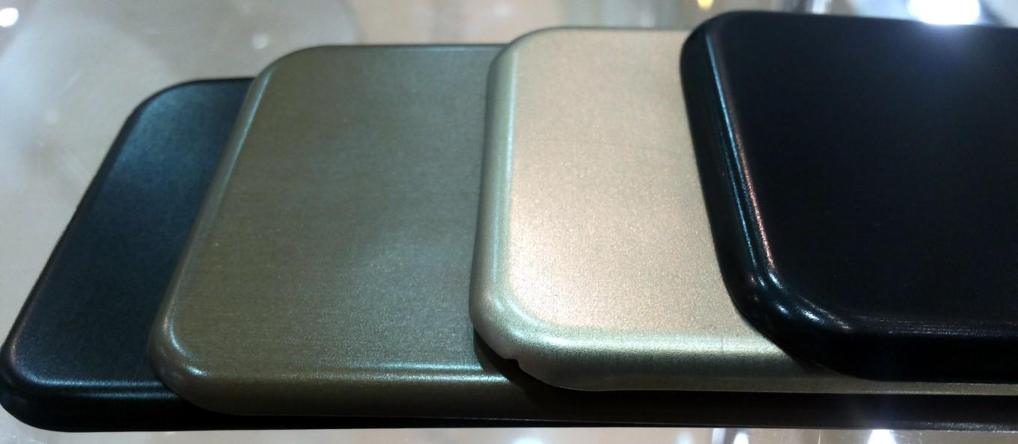
Корпуса мобильных телефонов / Mobile phone cases
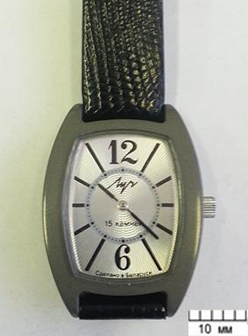
Корпуса наручных часов / Watch cases
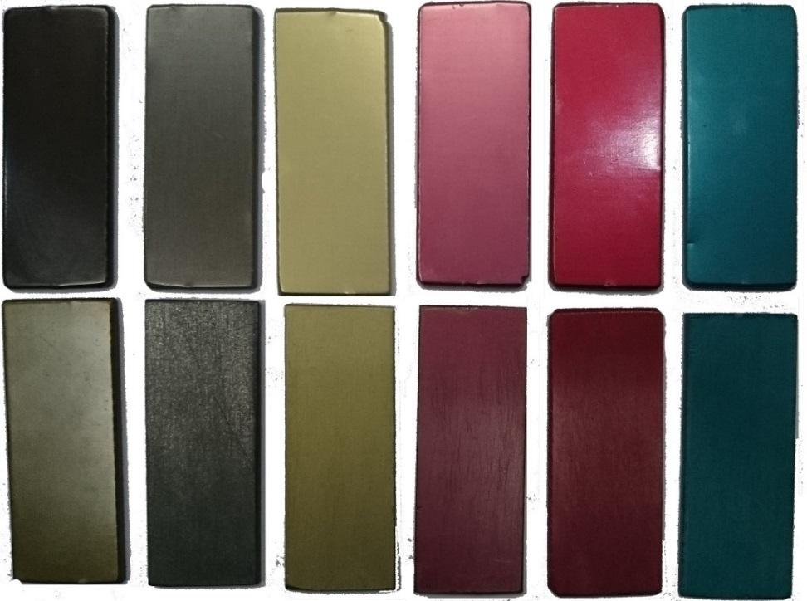
Образцы с оксидированного алюминия с окрашиванием / Samples with oxidized aluminum with coloring
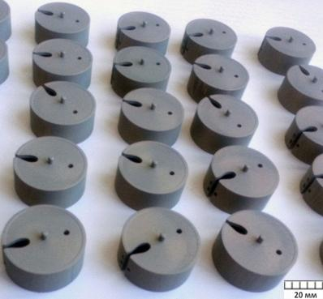
Детали топливной системы автомобиля / Machinery parts
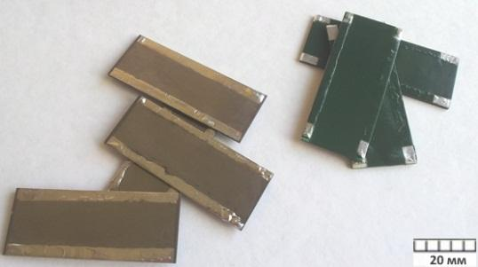
Нагреватели для LED мониторов / LED lamps

