
Dear colleges!
We inviting you to take part in the

XVI INTERNATIONAL SCIENTIFIC AND TECHNICAL CONFERENCE «ADVANCED METHODS AND TECHNOLOGIES
FOR MATERIALS DEVELOPMENT AND PROCESSING»

1-3 October 2025, Minsk, Belarus
THE MAIN AREAS OF FOCUS OF THE CONFERENCE:

1. Technologies and Equipment of Materials Processing.
2. Functional Materials.

Conference Calendar:
Acceptance of articles, letters of guarantee and applications for participation till 12.05.2025
Acceptance of the organisational fee till 30.10.2025
Arrival of conference participants 01.10.2025
Conference working period 01-03.10.2025
Departure of conference participants 03.10.2025

Form of participation:
On-site:
- with a plenary report;
- with a section report.
• Absentee (only for foreign citizens).
• Providing a poster presentation.

Information for conference participants
To participate in the conference it is necessary to send an application form, an article in the form of a file in DOC or DOCX format and an article with the authors' signatures in PDF format (the file name should include the name of the contributor and the first two words of the title of the article), figures in the form of separate files, an expert opinion on the permission to publish in the open press, a letter of guarantee on payment of the organisational fee to the Organising Committee at phti.org@gmail.com.

The submitted articles are subject to mandatory peer review.

The Organising Committee reserves the right to reject articles that have received a negative review. Articles that do not meet the design requirements and received by the Organising Committee later than 12 May 2025 will not be considered and will not be returned. Conference working languages: Russian, English.

The Organising Committee
Zaleski V.G. (chairman)
Laskovnev A.P. (deputy chairman)

Members:
Alies M.Yu. (Russia)  Alymov M.I. (Russia)  Bakhanovich A.G. (Belarus)  Belyi A.V. (Belarus)  Grigoriev A.Ya. (Belarus)  Grinchuk P.S. (Belarus)  Dragunov V.K. (Russia)  Ilyuschenko A.F. (Belarus)  Klubovich V.V. (Belarus)  Koval N.N. (Russia)  Kodirov T.Zh. (Uzbekistan)  Kozlov A.A. (Belarus)  Kolmakov A.G. (Russia)  Kolubaev E.A. (Russia)  Marukovich E.I. (Belarus)  Ming Cheng (China) | Myshkin N.K. (Belarus)  Nofal Adel (Egypt)  Poddubko S.N. (Belarus)  Ramazanov K.N. (Russia)  Rogachev A.A. (Russia)  Rubanik V.V. (Belarus)  Trubitskij R.E. (Belarus)  Uglov V.V. (Belarus)  Fedosyuk V.M. (Belarus)  Kharitonchik S.V. (Belarus)  Chizhik S.A. (Belarus)  Shaochuan Fеng (China)  Sheleg V.K. (Belarus)  Shi-Hong Zhang (China)  Shalabyto N.N. (Belarus)  Shcherbakov S.S. (Belarus)  Sun Chaoyang (China)
Program Committee
Volochko A.T. (Chairman)
Basalaj A.V. (Deputy Chairman),
Smyaglikov I.P. (Deputy Chairman).
Members: Latushkina S.D., Pokrovskij A.I., Pobol I.L.

Address of the conference organising committee:
Address of the conference organising committee:
10, Akademika Kuprevicha str., 220084, Minsk,
Republic of Belarus; tel./f. (+375 17) 369-76-93
Contact phones, fax, e-mail
Kartuzava Alesia
Tel. (+375 17) 342 37 06, (+375 29) 150 27 87
Olga Tolkacheva
Tel. (+375 17) 361 55 52
E-mail: phti.org@gmail.com
Registration of applications and acceptance of articles:
Natalia Pobiarzhina
Tel. (+375 17) 338 86 64, (+375 29) 758 74 50
E-mail: phti.org@gmail.com

Organisational fee

Payment of the organisational fee on the basis of the concluded contract includes the costs of service, reviewing, editorial and publishing preparation and publication of the conference materials.
Organisational fee in Belarusian rubles, Russian rubles and Chinese yuan:

- 400.00 Belarusian rubles (11000.00 Russian rubles, 1000 RMB), including 20% VAT - on-site participation;

- 200.00 Belarusian rubles (5500.00 Russian rubles, 500 yuan), including 20% VAT - absentee participation.

-Postgraduate students, Master's students - pay 50% of the organisational fee.

In the payment order in the column «Purpose of payment» should be indicated Organisational fee for participation in the XVI ISTC name of the speaker.

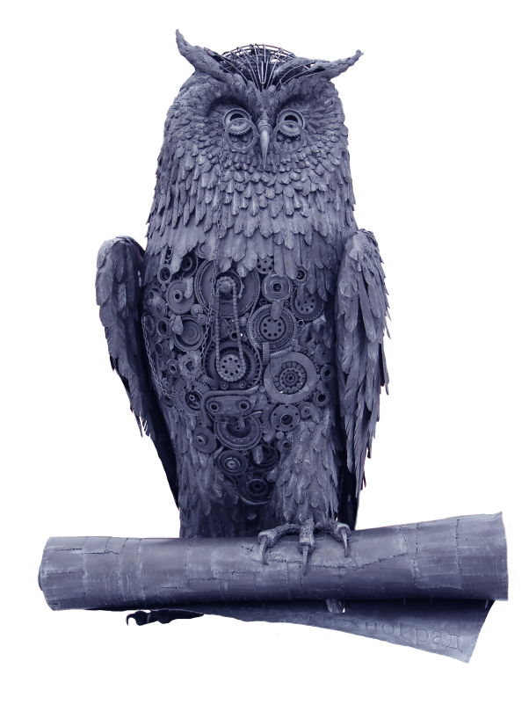
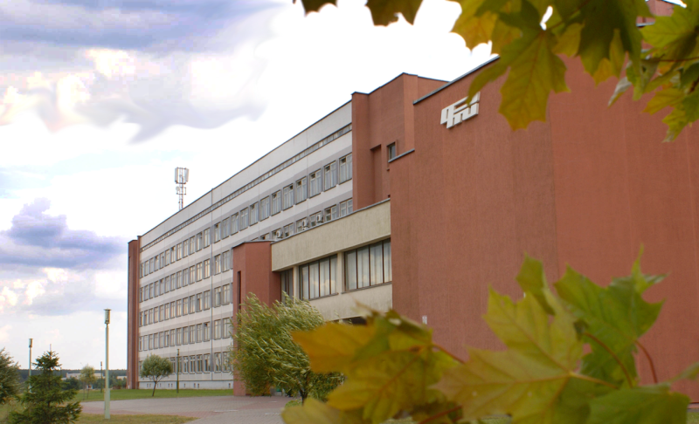
Application form
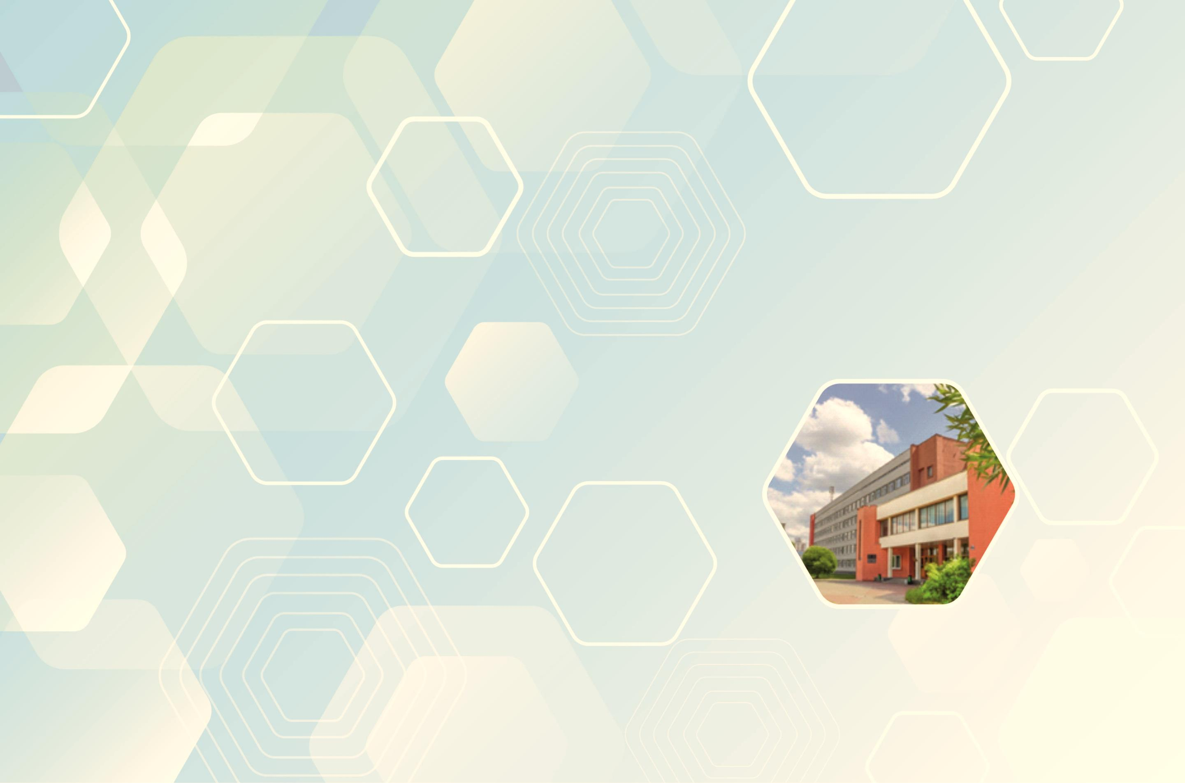
(Submitted by 12.05.2025)
for participation in the ХVI International Scientific-Technical Conference
«ADVANCED METHODS AND TECHNOLOGIES
FOR MATERIALS DEVELOPMENT AND PROCESSING»
October 01–03, 2025,
Minsk, Belarus

First and last name (full): ______________________
___________________________________________
Academic degree: ____________________________
Academic rank: ______________________________
Position: ___________________________________
Article title and authors: _______________________
___________________________________________
___________________________________________
___________________________________________
___________________________________________
in Conference section № ______________________
Participation in the Conference: on-site (plenary, section or poster presentation), absentee participation
(please, underline)
Organization (full and abbreviated name)
___________________________________________
___________________________________________
___________________________________________
Mailing address: ___________________________________________
___________________________________________
___________________________________________
Tel. _________________ Fax ________________
E-mail ____________________________________

Hotel reservation (underline, specify single or double room and estimated date of arrival)
● yes ● no

Signature _______________ Date ______________

REQUIREMENTS FOR THE LAYOUT OF THE ARTICLE
One author (co-author) may submit
no more than three articles.

The text should be typed on a computer in Microsoft Word in one column using Times New Roman font. Font size - 11 pt; line spacing - 1; all margins - 2.5 cm; orientation - portrait. The UDC index is written in the upper left corner of the first page. On the following lines, the following elements are placed in the following order in Russian, then in English (only in English for foreigners):

1. Title of the article.
2. Initials and surname of the authors (an author (co-author) can submit no more than two articles).
3. Organisation, country.
4. The abstract should briefly contain the purpose, method, results, conclusion. The volume of the abstract is no less than 500 symbols.
5. Key words.
6. E-mail of the author/authors. Основной текст статьи должен быть поделен на заголовки и подзаголовки.

• The main text of the article should be divided into headings and subheadings.

• The list of references should be compiled first in Russian, then in English according to the international standard. The number of works cited should not exceed 15 sources.

• Illustrations, graphic images should be saved in TIFF, EPS, JPEG formats with a resolution of at least 300 dpi.

• The volume of the article should be not less than 14,000 printed characters and not more than 28,000 printed characters.

Application form, rules and an example of articles layout are presented on the website of PTI NAS of Belarus.
https://phti.by/nauka/konferenczii

NATIONAL ACADEMY OF SCIENCES OF BELARUS

STATE SCIENTIFIC INSTITUTION
"PHYSICAL-TECHNICAL INSTITUTE
NATIONAL ACADEMY OF SCIENCES OF BELARUS"

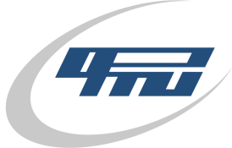

ХVI INTERNATIONAL SCIENTIFIC-TECHNICAL CONFERENCE

«ADVANCED METHODS AND TECHNOLOGIES
FOR MATERIALS DEVELOPMENT AND PROCESSING»

01–03 October 2025 г.
Minsk, Republic of Belarus

Information message – invitation

